Pokhara University

Level: Bachelor | Semester – Spring | Year : 2009
Programme: BE |  | Full Marks: 100
 |  | Pass Marks : 45
Course: Engineering Mathematics I |  | Time : 3hrs.

Candidates are required to give their answers in their own words as far as practicable.
The figures in the margin indicate full marks.

Attempt all the questions.

 | - Show that the function 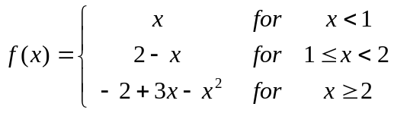  is continuous at x = 1 but not differentiable at x = 1.  OR  If y = sin⁻¹ x, show that  - (1 – x²) y₂ – xy₁ = 0  - (1 – x²) y_{n+2} – (2n+ 1) xy_{n+1} – n²y_{n}=0  b) State and prove Lagrange's Mean value theorem. Let 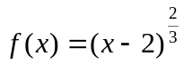 with x in [1, 4] can Lagrange's Mean  value theorem be applied in this function ? If not why ? | 7  8
 | - An open tank of a given volume consists of a square base with vertical sides. Show that the expense of lining the tank with lead will be least if the height of the tank is half of the width.  OR  Define asymptotes of the curves with different types. Find asymptotes of 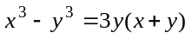.  - Evaluate 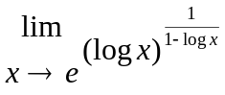. | 8  7
 | Integrate:  a. 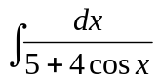  b. 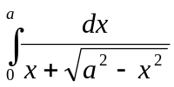  c. 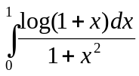 | 5  5  5
 | - Find the area bounded by the line 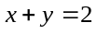, on the left by 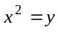 and below by x axis, by sketching neat diagram.  OR  Find the volume of the solid generated by revolving the region in first quadrant bounded above by , below by x axis and on the right by the line x = 1 , about the line x = -1 .  - Find approximate area bounded by given curves 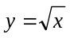from x = 1 to x = 4,by using Simpson’s and Trapazoidal rule with n = 4. Compare these values with exact value. | 7  8
 | - Find by vector method the equation of the plane which passes through the points (1, 1, -1), (2, 0, 2) and (0, -2, 1).  - What does scalar triple product give ? Explain geometrically and prove that 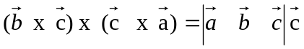. | 8  7
 | - Define eccentricity of a conic section and classify conic sections. Find the condition that the line lx + my + n = 0 may be a tangent to the ellipse 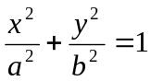.  - Derive the equation of the hyperbola in its standard form 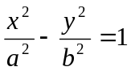. | 8  7
 | Attempt all :  - Find domain and range of the function 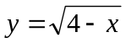.  - Find radius of curvature of the curve x= a cosθ, y= a sinθ.  - What will be the equation of the curve x² + y² – 10x – 12y + 36 = 0 if the origin is shifted to (5, 6) ?  - If 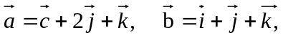 find unit vector along 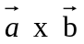.  - If f(x) = tanx. Is Rolle's theorem applicable in [0, π]. Give reasons. | 2x5

